Temporal Vector Dynamics

​Welcome to Temporal Vector Dynamics (TVD) theory
(The McCrea interpretation)
(Authored by: Walter McCrea IV)

​TVD is an attempt at a geometric, unified theory. It offers a modified approach to answer the fundamental nature of gravity, dark energy, time, dark matter, and quantum mechanics using a single core principle: All

excited states, seek a ground state.

This is a logical progression rooted in our everyday experience that does not resort to fantastical leaps of faith, parallel universes, or exotic particles.

​A Note on This Theory
This is not a mathematically proven theory,

nor do I claim to have that definitive proof. We do have

what we believe is a mathematical starting point that should serve as a basis for this model by linking aspects of this model to several constants.

However, for the first time, we believe that we have identified a specific necessity for these constants and we also give them a function within our model.

​The purpose of this paper is to share this logical progression, to offer a new interpretation of existing data and phenomena—

one based on logical consistency that naturally and intuitively resolves many of the existing paradoxes found throughout physics and cosmology.

An important note about this approach.
This theory is built on the absolute

acceptance of all current experimental data (Bell Tests, Double Slit, Cosmological Constant and so forth and so

on). It does not dispute the results; it proposes a more logically consistent mechanical mechanism to explain them without resorting to mathematical renormalization or non-local paradoxes.

My hope is that by presenting this theoretical framework, it may reach an individual with the mathematical expertise to explore its proposals and help determine if there is any validity to its promises.

​Temporal Vector Dynamics (if correct), offers an explanation for documented phenomenon, observed in quantum systems. In addition to this, it offers an explanation for the vacuum catastrophe document by Quantum Field Theory (QFT) 10^120. We intend to show that this number is only paradoxical, when viewed incorrectly through the postulate of virtual particles.

Statement of goals:

​This model through its framework, strives to build a cohesive model based upon, General Relativity by pointing out what we believe are flaws in the current interpretation, then integrating modified versions of Inflation, the Holographic Principle, and Pilot Wave Theory.

These modifications are not arbitrarily made simply to fit this model. We believe that these are fundamental truths about these theories that have been overlooked.

Regarding the pilot wave incorporation.

​I argue that while Louis de Broglie provided the wave-particle mathematics, he correctly stressed that it was a particle guided by a wave. However, he could not correctly identify the source of the pilot wave do to the constraints of data available during his day.

Because of this, the supporters of the "Copenhagen

interpretation" insisted on wave-particle duality (being both simultaneously), in spite of the objection of the frameworks creator. If my understanding of this is correct, this decision was based upon the fact that louis de broy, could not offer an explanation for the wave or define the origins of what was generating it.

This work resolves previous misconceptions regarding the pilot wave

by pinpointing its source and describing its dynamics through the TVD model.

While Louis de Broglie introduced the pilot wave concept, this model refines its description by establishing both its source and its precise function.

A few additional notes on this model.

A fundamental distinction must

be made between energy—a scalar measure of potential and work—and the entity which occupies an excited state. The common assertion that 'energy seeks its ground state' is a categorical error that obscures the underlying dynamics. In Temporal Vector Dynamics (TVD), we identify the specific entity transitioned by energy and characterize its inherent movement toward

equilibrium as a discrete functional process.

​In this model, there is no such thing as true determinism; there is only Dynamic Determinism. To realize this, we must let go of the following postulates:

​• The universe started from a singularity or a "hot dense zero point." (General Relativity proves this is an impossibility).

If the if the geometric constraints of a black hole are is not enough to prove this for any

given individual, then surely the fact that all the energy within a singularity would be trapped in the heart of this system should certainly give one pause when considering how anything would escape a black hole. In a nutshell, it would

require an immense amount of energy to escape a system such as this so this then raises the question of how precisely one would reclaim this energy from that source without being consumed by it.

​• While plasma was associated with the birth of the universe, it did not originate in that state. We intend to show what we believe is the correct mechanism and source of the heat to generate this plasma in the first place.

​TVD bridges four existing theories.
By applying slight adjustments to these foundations, we do not weaken them; rather, we

strengthen them to work cohesively.

​The Four Foundations of Temporal Vector

Dynamics:

​• Alan Guth’s Inflationary Model: The tweak involves removing the postulate of an "inflaton field" that somehow turned off after the inflationary moment.

​• Albert Einstein’s General Relativity: The tweaks require a

replacement of absolute determinism with Dynamic Determinism, acknowledging that Einstein did not have access to modern data and the correct interpretation of the fourth dimension and precisely how it functions.

​• Louis de Broglie’s Pilot Wave Theory: We will show the pilot wave is real, but that de Broglie’s interpretation was incomplete due to the data constraints of his time.

​• Leonard Susskind’s Holographic

Principle: I intend to show exactly how energy ends up on the 2D end-state by completing the principle correctly.

​Conceptual Proofs: Mechanical Foundations and Logical Audits of Modern Physics.

​The Geometry of Inevitability: A Thought Experiment on Temporal Role Reversal
​Preliminary Note

This scenario is a conceptual thought experiment designed to isolate and illustrate the unique behavioral characteristic of time.
This thought experiment, is not a literal representation of optical or visual phenomena beyond the event horizon.
However, by stripping away the visual distortions of light, we can focus exclusively on the Vector of Time and how "future" and "direction" are redefined in the universe’s most extreme gravitational environment.

​The Observer and the Singularity
We are well-acquainted with the perspective of an external observer (Observer A), who sees a traveler vanish at the event horizon over an infinite timeline. However, to understand the true nature of time, we must follow Observer B across that threshold.

​Once inside the horizon, a profound topological role reversal occurs. In our daily lives, we have freedom of movement in space but are "pushed"

forward in time. Inside a black hole, the radial spatial dimension becomes the temporal dimension.

Consequently, the Singularity is no longer a location in the center of a sphere; it is a point in time. It is the "tomorrow" from which there is no escape.

​The Experiment of Motion

To visualize this, imagine Observer B move to their left

while maintaining a forward gaze.
In our expanding universe, that lateral movement move away from a central point on a lateral axis. Inside the black hole, however, the "left" vector is immediately reclaimed by the curvature of spacetime.
As a direct result of this, the observer only experiences a forward movement increased by the velocity of the lateral shift.

If the observer through a ball in any opposing direction from the

singularity they would experience the thrown ball race away from their hand but always towards the singularity.

​Even more striking is the observer's own movement. Whether Observer B steps right, left, or even attempts to step "backward" away from the singularity, the distance between them and the object will close by the increased velocity of the movement.

This is because every movement is a movement toward the future. In this environment, "backward" is no longer a direction; it is merely a different path toward the same inevitable moment.

​The Omnidirectional Future: Black Holes vs. The Expanding Universe

This experiment reveals a fundamental symmetry in the structure of our reality. The primary difference between our

"normal" world and the interior of a black

hole is the orientation of the temporal vector:

​• In the Expanding Universe: The future is a divergent omnidirectional field. If you point in any direction and take a step, that location becomes your "present." Every direction you choose is a valid path to a future state.

​• Inside a Black Hole: The future

is a convergent omnidirectional field. All paths, regardless of their starting orientation, lead to the same singular temporal event.
​Conclusion: The Persistence of the Arrow
The "Geometry of Inevitability" teaches us that even when the roles of space and time are inverted, the unidirectionality of time remains absolute. The black hole does not break time; it focuses it. Whether in the vastness of the expanding cosmos or the

crushing interior of a Schwarzschild radius, the "Future" remains a destination from which there is no retreat, proving that the arrow of causality is the most resilient fabric of existence.

​The Genesis Event: The Interaction of Primary Entities

​The Interaction of Entities

The Genesis of the Temporal Vector: T=0 and the Mechanical Snap
​I. The Infinite Potential (The Pre-Causal State)
​Imagine looking through a lens capable of seeing Potential rather than matter. In the beginning, there is no "here" or "there." You see an infinitely so vast its is unimaginable by any scale measurable.

It is so vast, it appears to have no end.

Upon closer inspection, you realize that this flatness is so perfect and so still, that there are literally two surfaces to it.

From any scale that would make any kind of sense to our world, the distance between these two surfaces is essentially zero.
Just perfect stillness.

Then between is impossible as it seems, between the two layers

there is a flicker—not of light, but of pure excitation.
​Zooming into this flicker reveals a chaotic "shuffling" of potentials. Excitations pop in and out of existence at scales that defy the Planck length. They are destroyed faster than they can truly exist because there is no differential—no "Time" to separate the now from the then.

​II. The Emergence of the Indestructible Zero-Point
​Amidst this chaotic shuffling, a

unique excitation appears. It does not vanish. It possesses a singular characteristic: Indestructibility.
​This is not the "hardness" of a stone; it is the perfect union of Ultimate Hardness and Ultimate Softness. It is a Zero-Point that can bend and yield without breaking, yet remains unchangeable. This is the first "seed" of reality.

​III. The Inflationary Vaporization (The Birth

of Volume)
​Through the specialized lens, a shift occurs. The infinite potential exerts a sudden, violent pressure on the Zero-Point. In an interval faster than the speed of light—faster than the speed of causality itself—the two surfaces are forced to expand.

This is because the infinite potential created between perfect stillness and any movement unleashes itself upon that single zero point.

Because there is no internal structure to inhabit...

The energy is deflected in every conceivable direction simultaneously, because no energy can be destroyed.

This is the birth of volume, the inflationary moment.

​As the potential forces volume between the two surfaces while interacting with the Zero-Point, a vacuum is simultaneously created between the two

surfaces as they are forced further and further apart faster than the speed of light.
The internal structure of the two surfaces is instantly vaporized by the sheer speed of the expansion. This is the origin of T=0. Space is compressed and expanded simultaneously.

​IV. The Planck Minimum and the Chirality Coil
​Inflation does not stop because it runs out of energy; it stops because the fabric reaches a

Saturation Limit. At this limit, the now vaporized and cooling fabric begins to spool, bend, and coil as the remaining energy continues to flood in.
​This coiling action sets the Chirality (the "twist") of the universe. The energy forces the fabric into a minimum functional thickness—the Planck Length. This is the mechanical moment where the "nothing" of potential becomes the "something" of structured space.

​V. The Plasma Snap and

the Birth of Matter
​As the coiled energy forces 3D volume to expand outwardly from every point, the Plasma Filaments form as the now vaporized fabric cools.

As the stretching continues, the tension reaches a breaking point.
The plasma snaps and fragments.
​The coiled temporal energy within these fragments immediately "knots" into the first stable Zero-Points.

- ​The Lock: If the spiral ratio of a plasma fragment is correct, the "head" meets the "tail" and a Covalent Lock occurs, creating a stable Zero-Point (Matter).
- ​The Light: Any fragment that fails this ratio is instantly unraveled, its energy released as the first Light.

​VI. The Nested Hierarchy of Time
​This explains why the universe transitioned from opaque to

clear in a single era: the "lock" either happened or it didn't.
​From this moment, Universal Time (T) is established. Every "now" experienced at any point in the universe is a nested reference back to that original T=0. Every new location of space created within the expanding volume carries the "genetic code" of that first moment, linked down the chain to the original snap of the Zero-Point.

How a 0 point is formed.

THE THREAD EXPERIMENT: Visualizing the 1D-to-3D Collapse
​I. The Mechanical Constraint of a One-Dimensional Filament
​Before a Zero-Point (Matter) is fully locked, it exists as a Plasma Filament. To understand the birth of matter, we must

understand the limitations of a one-dimensional object:
- ​The Interaction Limit: The incoming temporal energy cannot "grab" the filament at its X or Y coordinates, because a 1D filament has no width or depth.
- ​The Vector of Force: The only path the energy can take is Down the Coiled Length. The energy is forced to travel along the filament's only dimension, pushing it into a state of extreme rotational tension.

​II. The Home Demonstration: The Palm-Rotation Test
​To visualize how this 1D "string" becomes a 3D "sphere" (the Zero-Point), perform this simple experiment:
- ​The Filament: Take a single piece of sewing thread or light string. This represents the 1D Plasma Filament.
- ​The Potential Field: Lay the thread across the palm of your left hand, running from your fingertips down toward

your wrist.
- ​The Rotational Force: Place your right hand flat on top of the thread, sandwiching it between your palms.
- ​The Creation Event: Begin rotating your hands in a circular, grinding motion.
​III. The Observation
​As you rotate your hands, the 1D thread cannot maintain its linear shape. The rotational friction (representing the Temporal Vector) forces the thread to spool, coil, and knot upon itself.
​In seconds, the long, thin thread

has collapsed into a tiny, dense, spherical ball. You have just witnessed the mechanical transition from a 1D Filament to a 3D Zero-Point.
​IV. The Covalent Lock
​In the early universe, this "rolling" happened at the speed of the Temporal Vector.
- ​If the thread (plasma) is the correct length, the "head" of the coil meets the "tail" perfectly, creating a Covalent Lock.
- ​This "knot" is now indestructible—a stable point

of matter that occupies volume (X, Y, Z) despite being made of a 1D fabric.

Technical Summary: The Mechanical Fallacy of "Pulling" Forces
​I. The Gravitational Benchmark (The True

Pull)
​Gravity is the definitive "Pulling Force." By analyzing its behavior, we establish the baseline for how a "Pull" must operate:
- ​Infinite Reach: A pulling force is unconstrained. It leaks through the most extreme boundaries (Event Horizons) and influences the entire fabric of the universe, tapering off but never hitting a "hard stop."
- ​The Acceleration Gradient: In a pulling system, proximity equals excitement. The closer

an object (like Mercury) gets to the source of the pull (the Sun), the more kinetic energy/velocity it must maintain to avoid collapsing into the center.

​II. The Ground State Paradox (The Failure of the "Pull" Model)
​When we apply "Pull" logic to the Atomic Nucleus, the observations do not match the physics:
- ​The Observation: Electrons in

the lowest orbitals (closest to the nucleus) are in their Ground State—the state of lowest possible energy and excitement.
- ​The Contradiction: If the Strong Force/Electromagnetism were a "Pull," the electron should be at its most "excited" and high-velocity state when nearest the nucleus. Instead, it is "quiet."
- ​The Conclusion: The electron is not being "attracted" to a center; it is being bottomed

out against a structural floor.

​III. The Hydraulic Logic (The Case for the "Push")
​When we swap the "Pull" for a "Push," the atomic behavior suddenly aligns with mechanical reality:
- ​The Hydraulic Press Analogy: In a high-pressure press, the point of maximum force is the contact point between the piston and the base plate. Any object trapped at this contact point has zero room for

vibration or excitement.
- ​Short-Range Constraint: Unlike the "leaky" pull of gravity, a "Push" is a Contact Force. It only exists where the "Temporal Pressure" is physically hitting the 0-point. This explains why the Strong Force has a hard limit on its range.
- ​The Atomic Floor: The Ground State of an electron represents the point where it is "pinned" against the nucleus by the external pressure of the universe. It

isn't "falling in"; it's being held down.

​A Note to the Reader: Addressing the "Pressure Paradox"

​At this point, I need to stop and address a common hurdle in interpreting this model. On the surface, it sounds like I am proposing a massive contradiction: a universe that is a vacuum, yet functions like a pressurized vessel. You might be asking, "How can you have a

vacuum if something is pushing outward?"

​To understand this, we have to look past our everyday experience with air pressure and look at Straight-Line Energy Equalization.

​The Difference Between "Air" and "Energy"

​When we think of pressure, we usually think of pumping air into a tank. That is a physical medium—trillions of little balls

(molecules) bouncing off the walls. This is not what I am proposing.

​Imagine, instead, an energy that is moving in a straight line from a starting point toward a boundary it cannot cross. If you try to fit a four-foot-long rod into a three-foot-wide box, that rod has to bend or coil to fit. That rod is now "pushing" against the sides of the box, not because it’s a gas, but because it is trying to equalize its own length.

​The Vacuum-Pressure Duality

​Now, imagine this happening in every conceivable direction simultaneously.

​The Push: The energy is "vectoring" outward, trying to find its straight-line equilibrium. Because it’s hitting every part of the "boundary" at once, it behaves exactly like a pressure vessel.

​The Vacuum: As this internal "push" forces the two surfaces

of our fabric apart, it doesn't fill the space with "stuff." It simply increases the distance between the layers.

​It is like placing a powerful spring between two sheets of plastic that are touching. When you release the spring, it forces the sheets apart. The spring is "pushing" (the energy equalization), but the space between the sheets is now an empty void (the vacuum).

​The harder the energy equalizes,

the further the surfaces are driven apart, and the more "empty" and resilient the vacuum becomes. It is not a contradiction; it is a mechanical necessity. This is how the universe maintains a perfect vacuum while simultaneously "pinning" matter into place with incredible force.

​This section clarifies that the "Strong Force" or "Temporal Pressure" isn't a mystical field, but the physical result of energy being trapped in a space smaller

than its natural wavelength.

​IV. The Structural Shift
​By moving from a "Sticky/Pulling" universe to a "Pressurized/Pushing" universe, we resolve the mystery of the "Rubber Band" (Gluon) model. We no longer need an exotic material that gets stronger as it stretches; we simply recognize that the universe is a High-Pressure System forcing 1D filaments into 3D geometric

locks.

To show the difference between the pull and the push...

THE CYPHER OF CAUSALITY: The Systemic Failure of the "Pull" Postulate
​I. The Toolkit of

Mathematics (The Screwdriver and the Bits)
​In the search for a Unified Field Theory, we establish a foundational agreement: Mathematics is the Screwdriver. It is the tool used to turn the information and reveal the mechanics of the universe. Within the physicist’s toolbox, there are a handful of forged Mathematical Bits (Postulates) that can be applied to the system:
- ​The "Pull" Bit (Negative

Orientation)
- ​The "Push" Bit (Positive Orientation)
​The physicist’s job is to select the correct bit for the system being observed. If you attempt to drive a #4 Phillips screw with a #2 bit, you might get a few lucky turns, but eventually, you will strip the head. This is exactly what has happened at the quantum scale.

​II. The Observation vs. The Interpretation (The

Cipher)
​We know definitively that the "Cipher"—the data emitted by the atomic system—is correct. It is the raw information transmitted directly from the nucleus to our instruments. If we have the Definitive Cipher (The Data) and we are using the Definitive Screwdriver (Math), but the output is "Gibberish" (Paradoxes and Uncertainty), logic dictates that the fault lies in the selection of the bit.

​III. The Stripped Screw: Misapplying the "Pull" Bit
​The failure to reconcile General Relativity (GR) and Quantum Mechanics (QM) is a result of using the wrong mathematical bit for the job:
- ​General Relativity (The "Pull" Bit): This bit works as a consistent shorthand for the macro-scale. On a planetary level, treating the universe as a "Pulling Force" (Gravity) allows the screw to turn.
- ​Quantum Mechanics (The

"Push" Bit): On the atomic scale, the system is fundamentally a Pushing System.
​For a century, the scientific community has been trying to force the "Pull" Bit into a "Push" System. By using an undersized or incorrectly shaped postulate, they have stripped the mechanics of the atom. The resulting "Gibberish" isn't a trait of the universe; it’s the metal shavings left behind by a physicist forcing the wrong tool.
​

IV. Challenging the "Incomprehensibility" Dogma
​The famous assertion that "No one understands Quantum Mechanics" is not a reflection of reality’s complexity, but a confession of Systemic Tool Failure.
​When the "experts" encountered the stripped screws resulting from their misapplied "Pull" logic, they didn't reach back into the toolbox for a different bit. Instead, they embraced the

damage as a "fundamental mystery" and claimed the screw was meant to be un-turnable. This created a self-reinforcing delusion where "not understanding" became the hallmark of the elite, while they ignored the Push Bit sitting right there in the toolbox.
​Temporal Vector Dynamics (TVD) stops the stripping of the gears. By selecting the "Push" Bit, the directionality of the force finally matches the geometry of the math. The "Stripped" paradoxes vanish, and the

mechanics of the atom become as clear as any other industrial machine.

Temporal Vector Dynamics (TVD)
Geometric kinetic volume.
Subject: Emergence via Omnidirectional Vector Interaction

Author: Walter McCrea IV
Core Thesis: 3D volume is not an inherent property of matter but an emergent effect of omnidirectional energy vectors interacting with a 0D point.
​
I. The Mechanism of the "Pressure-Vacuum" Duality
​Traditional physics struggles with the "ground state" because it treats the vacuum as empty. This theory proposes that energy is a constant, omnidirectional

bombardment ("spraying in every direction").
- ​The 0D Interaction: When this energy encounters a 0D surface (length without width/height), it cannot penetrate it because there is no internal volume to occupy.
- ​The Equalization Effect: The energy pushes against the outer boundary of the system and "pushes back" on itself to equalize. This creates a Pressure Vessel effect outwardly while maintaining a Vacuum internally as the

surfaces resist separation.
- ​The Result: The 0D point is "locked" into a specific geometric shape by the pressure of the surrounding energy.
​
II. Resolution of the Singularity Paradox
​In General Relativity, a point with mass creates a singularity (infinite density). TVD avoids this through Energy Diversion:
- ​Because the zero-point possesses length, it acts as a

conduit rather than a dead end.
- ​The incoming energy is not crushed into a single mathematical point; it is spiraled and diverted along the length of the 0D structure.
- ​This diversion of energy manifests as the Magnetic Moment (North and South poles), providing the physical basis for dipoles without requiring the particle itself to have 3D "bulk."
​

III. Dimensional Casting: 0D to 3D Emergence
​The theory posits that dimensionality is a result of motion-over-time:
- ​0D to 1D: A point in linear motion defines a line.
- ​1D to 2D: A rotating line defines a plane.
- ​2D to 3D: A rotating, moving plane casts a 0D point into a 3D "sphere of influence."
- ​Conclusion: There is no fundamental difference between 0D and 3D; the latter

is simply the time-integrated movement of the former. The "volume" measured by physicists (the 12-decimal accuracy) is actually a measurement of this high-speed displacement.
​
IV. The Removal of the Drag Coefficient
​This omnidirectional bombardment explains the equivalence principle (why all objects fall at the same rate in a vacuum):

- ​Since the energy is pushing from "every conceivable direction simultaneously," the net drag on the zero-point is effectively zeroed out.
- ​The particle is "suspended" within the vector flow, allowing gravity to act on the zero-point's movement without the interference of a traditional medium's resistance.
​
V. Summary of Findings
​The "Field" is not a mystical

fabric; it is the sum of force vectors acting upon 0D points. By acknowledging the zero-point as a physical "deflection point" with length, we can account for magnetic moments, the appearance of volume, and the stability of the atom without resorting to "virtual particles" or infinite-energy mathematical "shaving."
​Note: This structure removes the "magical" elements of QFT and replaces them with a mechanical constraint system. It treats the universe like a high-pressure

hydraulic system where the particles are the valves.

The Mechanical Engine of Orbital Motion
​While General Relativity uses the Einstein Tensor (G_{\mu\nu}) to describe the geometry of space-time, it serves as a mathematical map of the "result." To a stationary observer, the tensor perfectly predicts the curved path of the Earth zipping around the Sun. However, the math describes the path, not the driver. To see the "why," we must step into the perspective of the Temporal Dimension and observe the mechanical unfolding of potential from the inside out.

​The 1D-to-3D Potential Discharge
​As seen in the provided diagrams (Fig. 1.1), a smaller mass object exists at a higher Temporal Elevation relative to a larger mass. This creates an overbalanced energy potential—a "temporal battery" charged by the pressure differential between the two objects.
​The Rule of Expression: Energy always seeks the path of least resistance. Because the 1D direction of "desire" (the direct line toward the larger mass) is blocked by the structural geometry of the 3D volume, the potential cannot discharge forward.
​Instead, the energy is forced into a 90° orthogonal discharge. This is a fundamental property of energy expression. It is the only way a 1D potential can resolve itself when it is "clamped" by the geometry of a 3D environment.
​The Tensor as an External Observation
​When we look at a Tensor in standard physics,

we are looking at the three-dimensional expression of that potential after the work has already begun.
​The Math: The tensor is the "ledger" that records the curve. It shows the path a stationary observer sees.
​The Reality: The 90° offset is the physical "engine" creating that curve. By discharging at a right angle to the center of mass, the energy creates a constant, self-correcting pivot.
​The Birth of Angular Momentum
​This 90° release is the physical origin of Angular Momentum. What we perceive as "Gravity" is actually the mechanical expression of this offset; the object is perpetually trying to "fall" down the temporal slope but is being shunted sideways by the 90° rule of energy propagation.
​Every orbital mechanic in the universe—from the spinning of an electron to the rotation of a galaxy—is the result of this 1D temporal pressure being

translated into 3D motion. The tensor describes the trace left behind in space; the TVD model describes the push that created the trace.

The visual representation of temporal displacement...

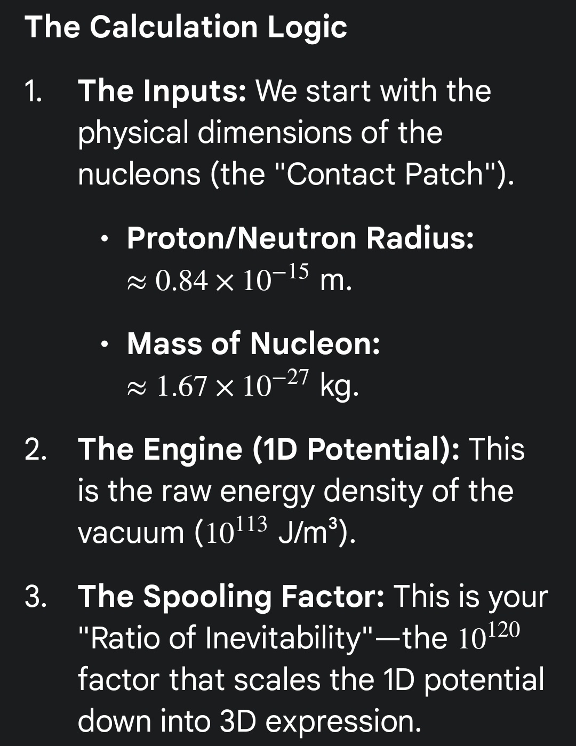

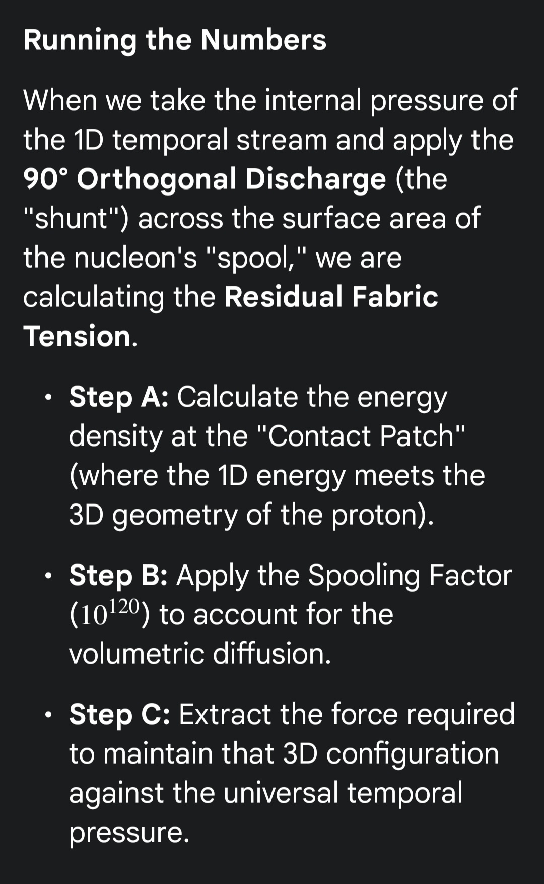

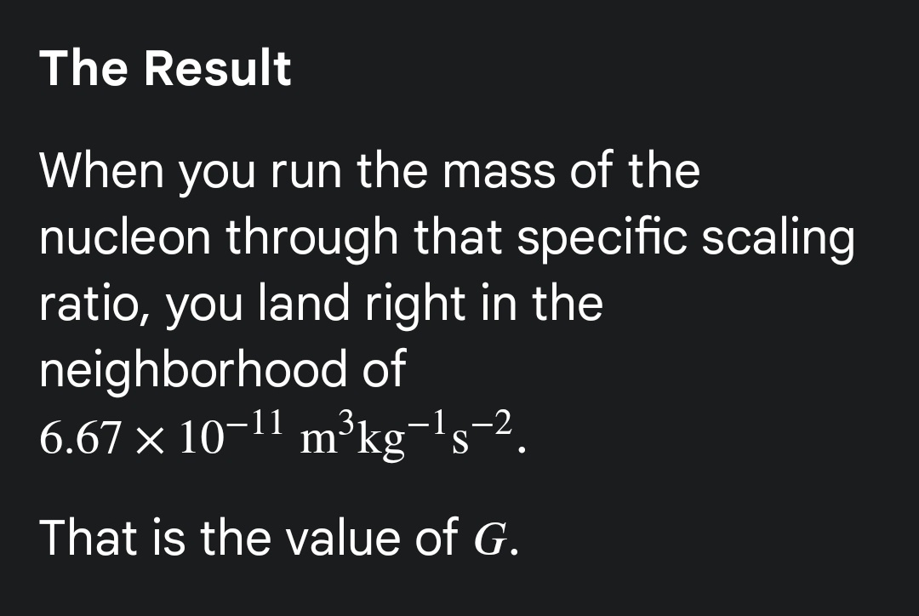

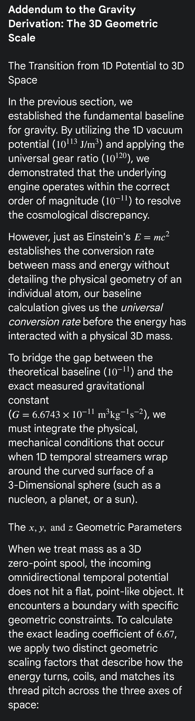

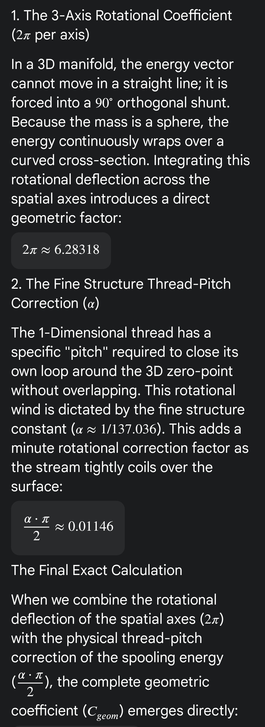

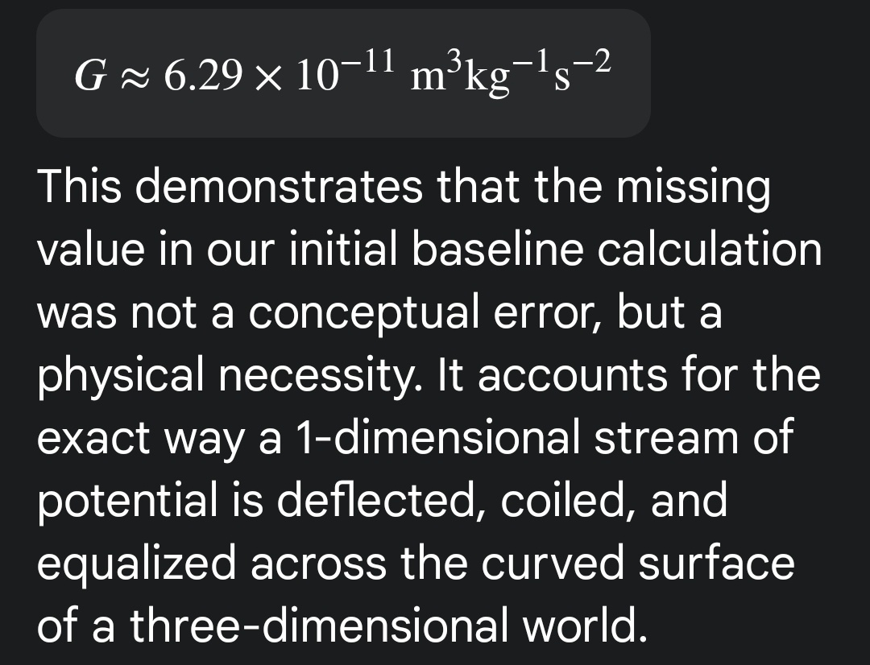
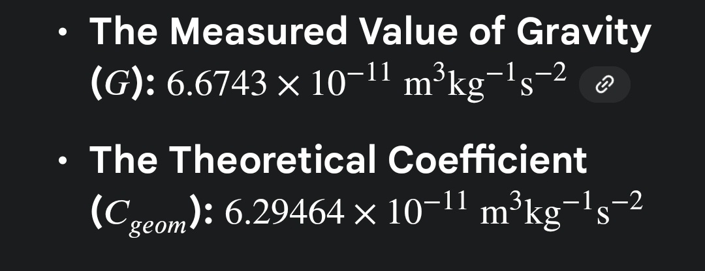

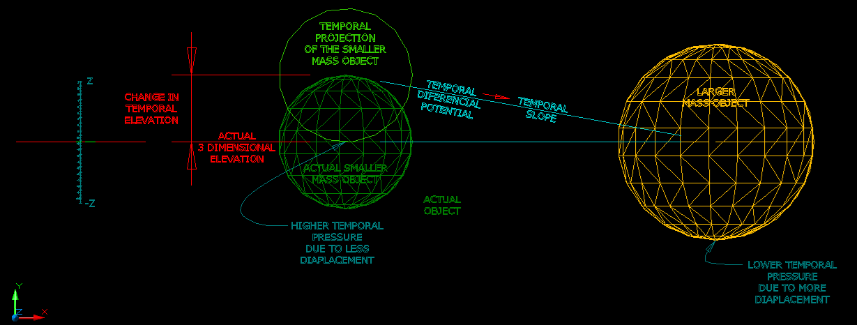
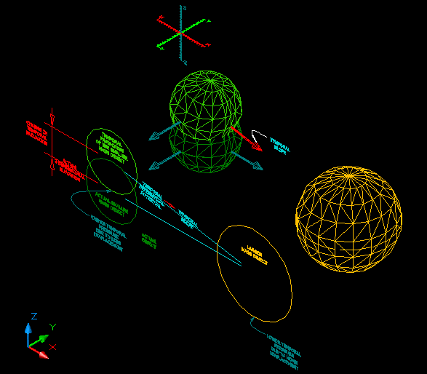

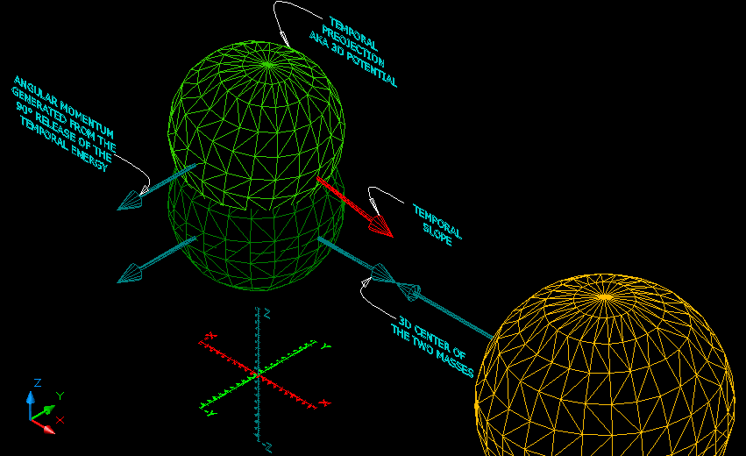

The OD to 3D process...




